

**INDIAN INSTITUTE OF INFORMATION TECHNOLOGY, NAGPUR**

C/o Regional Telecom Training Centre (RTTC) BSNL, Seminary Hills, Nagpur-440006 091-0712-2801369, Email: registrar@iiitn.ac.in

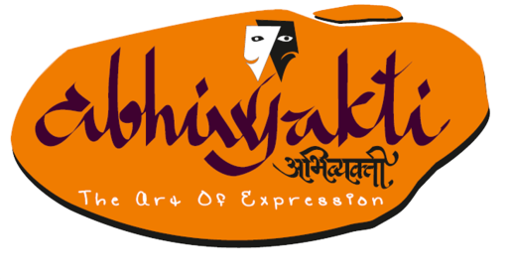---------------------------------------------------------------------------------------------------------------------------------------------------

Presents Antara

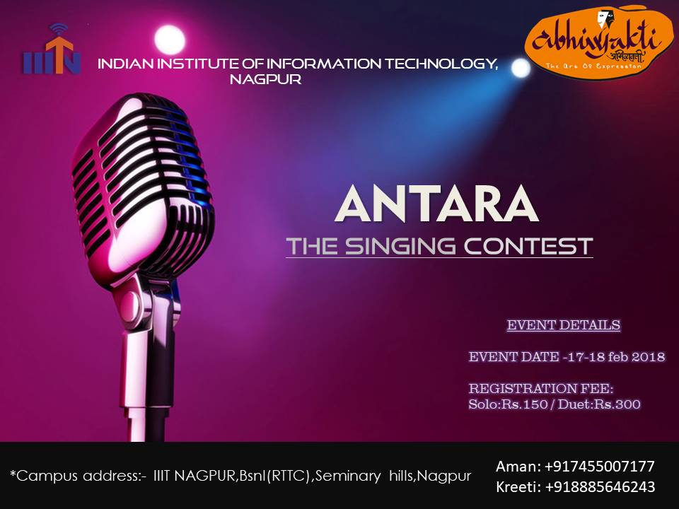

**About the Event:**

“Then the singing enveloped me. It was furry and resonant, coming from everyone's very heart. There was no sense of performance or judgment, only that the music was breath and food.”

One of the greatest joys and freedoms is to sing what with your heart and soul, it metamorphosis’s your thoughts into the listener's mind. Let your songs and voice transcend all the boundaries, sing like you have only today to express yourself, sing for the moment, sing for the laughter and sing for the tears..

Antara is the singing competition of the annual cultural fest of IIIT Nagpur, Abhivyakti. This competition includes both solo and duet performances.

**Rules:**

* Participants have to register online by filling up the goggle forms provided on the official website www.abhivyakti.ga.
* Participants are supposed to register at the Student Activity Centre.
* Songs should only be in “**Hindi language**”.
* Maximum time of 5 minutes will be allotted per performance.
* No musical instrument would be allowed.
* Karaoke/background score would be allowed. The tracks are supposed to be brought in pen-drive or U.S.B.
* It is the responsibility of participant to submit the tracks to concerned person of Team Abhivyakti.
* Participants must have a valid college identity card.
* The choice of songs should be appropriate and no vulgarity will be entertained.
* If any unfair practices are found during the event then it will lead to disqualification of the following participants.
* You need to get ready along with your performance at least 10 minutes before the event starts.
* Every participant(s) are required to fill up the “undertaking”.
* **Please, do collect your identity cards available at the registration desk.**

**Note:**

* The participants of solo and duet will be judged separately.
* In case of any discrepancy, decision made by the Team Abhivyakti’18 will befinal.
* The event may be held as various rounds as per the convenience of TeamAbhivyakti.

**Registration Fee**: **INR 150 for solo.**

**INR 300 per duet.**

**\*Prizes**: **1st winner : INR 2000 for solo**

**: INR 3000 for duet**

**2nd winner : INR 1500 for solo**

**: INR2000 for duet**

**Contact Us:**

Aruna Mallela: 9440615831

Divyasri Koshike: 7330901399

\**prizes can be changed*